**GIT**

Git is distributed version control system, Git is a software and it is used to store files or projects like web development files, android app files, documentation files.

* Install Git for windows. (64-bit OS)
* Create an empty folder on desktop name it Learning_Git
* Open folder and right click on it and select Git Bash Here option.
* Set $ git config --global user.name muneebullah
* Set $ git config --global user.email muneeb@aptechnk.com
* Open vs code through code . in Git Bash here prompt in the folder
* To create a repository in Git you can either do initializing or cloning
* If you are doing cloning then all the data comes from the server
* If you are initializing then you are starting from scratch.
* For initializing use $ git init
* Use ls -lart to find hidden folders
* We have created Git repository through init command
* git status is used to check status
* If your file is untracked track it by using command git add index.html
* Then check git status
* Then use command git commit

Press I and:

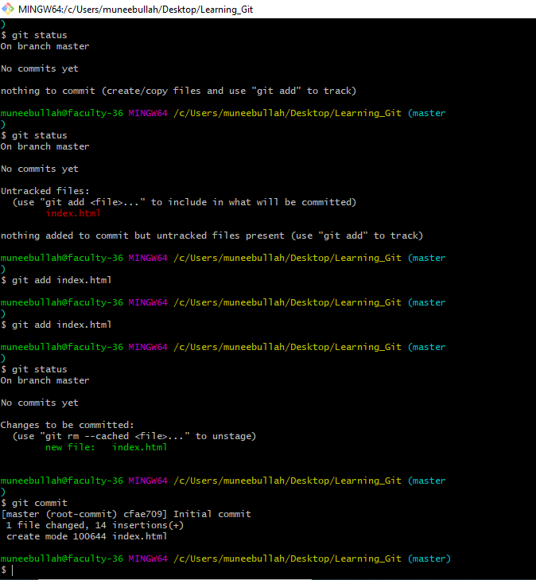

* To create file use command touch filename. Extension
* To send all files to staging area use git add -A
* git commit -m “Added more htmls”
* git checkout filename.extension is used to recover file
* to recover all files use git checkout -f
* use git log to check commit, author, Date, Time details
* Clear command use to clear terminal
* git log -p -number
* git diff is used to tell changes in file
* ls command is used to list all files
* to remove file use git rm filename.extension
* git status -s is used to check the details of file that whether it is modified or it is in working tree.

**Branches**

* Master branch is the by default main branch in git
* To create another branch use git branch branchname
* To check branches, use git branch
* To switch to another branch use git checkout branchname
* To create a branch and switch to it automatically use git checkout -b branchname

**Remote Repository**

* Create github account
* Create remote repository
* 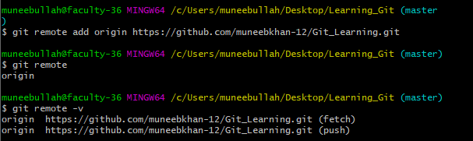
* Go to settings
* Then go to SSH & GPG keys section
* Click on generating SSH keys
* Then go to generating a new SSH key and add it to the ssh-agent